[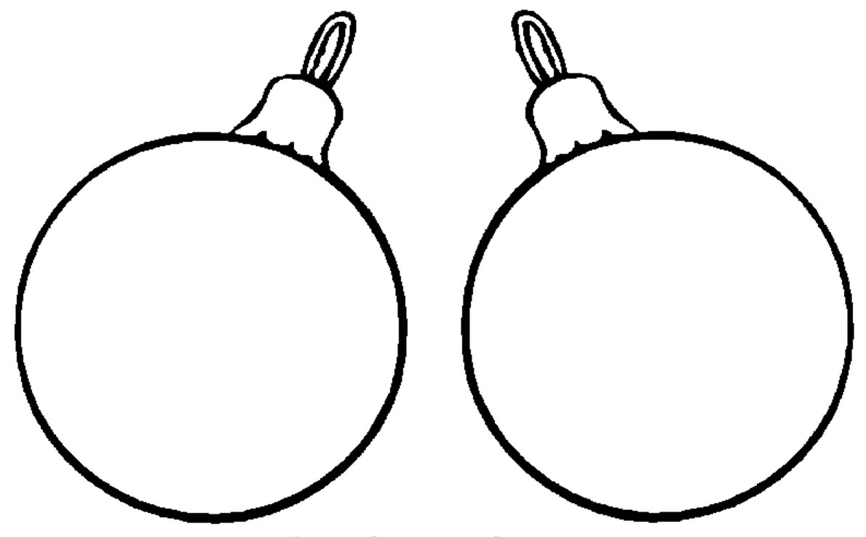](http://www.google.ru/url?sa=i&rct=j&q=&esrc=s&source=images&cd=&cad=rja&uact=8&ved=0ahUKEwj5x9KU7uTQAhUB2SwKHS2GA0MQjRwIBw&url=http%3A%2F%2Fpesochnizza.ru%2Fraskraski%2Fraskraski-elochnye-igrushki&bvm=bv.141320020,d.bGg&psig=AFQjCNGv8exe9Mdd4LSw1oBT4oxNSUcIpw&ust=1481295562146115)